***Project Final Report***

***On***

**Dark Town Cafe (Cafeteria Management System)**

Submitted in the partial fulfillment for the award of the degree of

BACHELOR OF ENGINEERING

**COMPUTER SCIENCE & ENGINEERING**



**Submitted to: Submitted By:**

Yana Srivastava (20BCS2279)

(Er. Kiranjeet Kaur Sandhu& Ecode-12258)Darshan (20BCS2353)

**Project Teacher (Supervisor)** Prisha Das (20BCS2302)

 Tushar Khajuria (20BCS1931)

Harsh Tyagi (20BCS1952)

**Co Supervisor Signature**

(Deepika&Ecode-11809)



**DEPARTMENT OF COMPUTER SCIENCE & ENGINEERING**

**CHANDIGARH UNIVERSITY, GHARUAN**

**June 2022**



## BONAFIDE CERTIFICATE

Certified that this project report **“_ DARK TOWN CAFE[Cafeteria Management System] ”** is the bonafide work of “ **Yana Srivastava, Darshan, Prisha Das, Tushar Khajuria** and **Harsh Tyagi ”** who carried out the project work under my/our supervision.

**SIGNATURE SIGNATURE**

**SUPERVISOR HEAD OF THE DEPARTMENT**

Submitted for the project viva-voce examination held on 19 May 2022__

**INTERNAL EXAMINER EXTERNAL EXAMINER**

**ABSTRACT**

This report is conducted in order to set the foundations upon which the final project will take place. The title of the project is: “Dark Town Café”.

The main target of this report is to conduct a thorough and in-depth analysis of the vast field of Software engineering and at the same time explore the opportunities and the conditions that could lead into building a successful website. The simplicity and ease of access of a menu are the main things that facilitate ordering food in a restaurant. A menu completely revolutionizes the patron’s dining experience. Existing programs provide an app that restaurants can use to feed their menus into websites and make it easier for the diners to flip, swipe & tap through the menu.

The purpose of this website is to automate the existing manual system to help the computerized equipment and full-fledged computer software, fulfilling their requirements, so that their valuable data/information can be stored for a longer period with easy accessing and manipulation of the same. The required software and hardware are easily available and easy to work with.

We here aim to provide the restaurants with a website menu that would recommend dishes based on a recommendation algorithm which has not been implemented elsewhere. We use a MY SQL server for storing the database which makes it inexpensive & secure. For User Interface we use HTML, CSS and JS for making our website attractive and responsive.

## ACKNOWLEDGEMENT

### It is my pleasure to be indebted to various people, who directly contributed in the development of this work and who influenced our thinking, behavior and acts during the course of study.

We are thankful to our Project Teacher or Supervisor **Kiranjeet Kaur Sandhu Mam** for her support, cooperation and motivation provided to us during the training for constant inspiration, presence and blessings.

We would also like to thank to our Co Supervisor **Deepika Mam** for her valuable suggestions and precious time which helps us lot in completion of this project.

Lastly, we would like to thank the almighty and our parents for their moral support and friends with whom we shared our day-to-day experience and received lots of suggestions that improved our quality of work.

## TABLE OF CONTENTS

| **S. No.** | **Title** | **Page No.** |
| --- | --- | --- |
| 1. | Introduction ………………………………………………   * 1. Related Work | 7 |
| 2. | Literature Review…………………………………………... | 10 |
| 3. | Design/Flow Process ……………………………………….  3.1 DFD Diagram  3.2 Use-case Diagrams  3.3 Sequence Diagram  3.4 Feature/characteristics identification  3.5 Project Screen Shots | 12 |
| 4. | Problem Definition …………………………………………  4.1 Problem Statement  4.2 Proposed System  4.3 Project Scope  4.4 Objective | 24 |
| 5. | Results Analysis and Validation ……………………………  5.1 Modern Tools Used In Design And Analysis  5.2 System Requirements  5.3 Result Analysis | 28 |
| 6. | Conclusion and Future Work………………………………..  6.1 Deviation from expected outcome and ways ahead  6.2 Achievements  6.3 Future Scope | 31 |

**List of Figures:**

1. Fig 3.1[Component Diagram]
2. Figure 3.1.1[Level Zero DFD]
3. Figure 3.1.2[Level 1 DFD]
4. Figure 3.1.3[Level 2 DFD]
5. Fig 3.2.1[use case diagram]
6. Fig 3.3.1 [Sequence Diagram]
7. Fig 3.5.1 [User Interface]
8. Fig 3.5.2 [Shop page]
9. Fig 3.5.3 [Add to cart]
10. Fig 3.5.4 [Check Out page]
11. Fig 3.5.5 [Login Page]
12. Fig 3.5.6 [Profile Page]
13. Fig 3.5.7 [Order History]
14. Fig 3.5.8 [Contact us page]
15. Fig 3.5.9 [Admin panel 1]
16. Fig 3.5.10 [Admin panel 2]
17. Fig 3.5.11 [Database 1]
18. Fig 3.5.11 [Database 2]

**Chapter - 1**

**INTRODUCTION**

The traditional system is a restaurant paper menu and ordering system is replaced with an electronic medium i.e. a website. Due to a digitalized system, the risk of manual errors is eliminated, thus eliminating the communication barrier.

The website displays all the information the customer needs to know about the order he has placed. It has been developed to override the problems prevailing in practicing manual systems. This software is supported to eliminate and in some cases reduce the hardships faced by this in existing systems. Moreover this system is designed for the particular need of the company to carry out operations in a smooth and effective manner.

This website is reduced as much as possible to avoid errors while entering the data. It also provides an error message while entering invalid data. It is user friendly. It can lead to an error free, secure, reliable and fast management system. It can assist the user to concentrate on their other activities rather than concentrating on the record keeping. It will help organizations in better utilization of resources.

This self-service fast food restaurant will be equipped with a user-friendly touch screen, a credit/debit card reader, and software for completing the process at the backend. For this system there will be a system administrator who will have the rights to enter the menu with their current prevailing prices. He/she can enter anytime in the system by a secured system password to change the menu contents by adding or deleting an item or changing its price.

Now when the customer enters the restaurant, he will place his order with the help of the touch screen using the intuitive graphical user interface, right from the selection of language till the payment confirmation. He will select from the food options according to his choice and the system will display the payment amount he has to make once he has finished with his order.

Customers get many benefits via online ordering; this helps the cafeteria to build long-lasting and profitable relationships with their customers. For making strong relationships with these users it is very important to focus on the customer as a whole and make sense of a flood of real-time information that goes well beyond demographics or shopping behavior.

There are two entities that will have access to the system. One is the admin and another one will be the registered user. Admin can add product details, view all the order details and can also view the sales of the products.

Users need to register with basic registration details to generate a valid username and password. After the user logins, it can view all the products that are recommended on the homepage compiled by the system based on the user's information. From the recommended menu card, the user can even further view its details and then if interested to order, the system gives an add to cart option for purchasing the product.

The system even has an AI bot with the help of which the user can get answers to queries like prices, facilities, etc. details of the cafeteria. This AIN't even converts text to speech. After selecting the particular food, users can pay for the particular food online. Users can view their order history of their purchased food. They can also show their delivery boy details too.

Every organization whether big or small, has challenges to overcome and manage the information. So, we design exclusive employee management systems that are adapted to our managerial requirements. This is designed to assist in strategic planning, and will help us to ensure that our organization is equipped with the right level of information and details of our future goals. Also, it allows us to manage work from anywhere anytime. These systems will ultimately allow us to better manage resources.

**1.1 RELATED WORK:**

The current system is paper based. Papers are used in restaurants for displaying the traditional menu cards, writing down the orders of customers, and storing the records of customers. The disadvantages of paper based systems are that papers can get easily damaged by stain marks; they can be lost due to fire or accidents or can get lost in general. Hence, time and money is wasted.

As traditional menu cards are paper based, any changes that need to be made in the menu will require reprinting of the entire menu card, leading to wastage. For small changes, reprinting the entire menu card is impossible. Changes in the menu card cannot be made dynamically. It is inefficient to access a particular record from the stack of papers. This system is time consuming. One has to call a waiter a number of times till he notices it, and wait for him to arrive at their table to take their order. Also the waiter can misinterpret the customer’s order since he is writing the order on paper, and the case of serving a wrong dish is possible. For placing any orders customers have to visit hotels or restaurants to know about food items and then place order and pay. In this method time and manual work is required.

While placing an order over the phone, the customer lacks the physical copy of the menu item, and lacks visual confirmation that the order was placed correctly. Every restaurant needs certain employees to take the order over phone or in person, to offer a rich dining experience and process the payment. In today’s market, labor rates are increasing day by day making it difficult to find employees when needed.

**Chapter – 2**

**LITERATURE REVIEW**

The system is implemented to reduce manual work and enhances the accuracy of work in a restaurant. This system manages and maintains the record of customers and their order online. This Android App has been made in a user friendly interface. So that customers can add and delete the food items easily.

[1]The menu card of different restaurants consists of various food varieties available in the restaurant. Through the place ordering menu, the customer can simply click and order the food. The messaging module tells the supplier to supply the particular food. Also the tracking module tracks the order. The billing system prepares the bill according to the delivered food. This system entirely reduces the unnecessary time. Every order is associated with an individual seat at the table, and orders are built one customer at a time, just like on paper, but with greater accuracy. Items can also easily be shared by the whole table, moved or modified, and noted and the cost can be calculated in real time.

[2] The purpose of the Canteen Management System is to automate the existing manual system by the help of computerized equipment and full-fledged computer software, fulfilling their requirements, so that their valuable data/information can be stored for a longer period with easy accessing and manipulation of the same. The required software and hardware are easily available and easy to work with.

[3]Cafeteria Management System is a computer system that helps the cafeteria to manage their cafeteria dairy process, such as order, reservation, redemption etc. The entire system consists of back end and front end, with the back end being an offline application and the front end being a web site. The offline application allows the cafeteria to manage the cafeteria information and manage the dairy process such as seat admission and order. And the system allow cafeteria to manage their meal menu and promotion. And all the updated meal menu and promotion will be show on the web page automatically upon the completion of updating.

[4]The perspectives of organizational, marketing and strategic management theories provide a reliable theoretical groundwork to understand the important managerial aspects of menu. For instance, organization theory explicitly emphasizes the influence of the external environment both on the decisions of firm managers and the survival of firms in the long run.

[5]More specifically, the external environment is one of the central themes of organization theory and the relevant studies primarily propose that managers essentially consider the influential external factors that create uncertainty, diversity and volatility while making their decisions. Planning and operating menus in a restaurant context involve considering external factors such as customers, rivals, and vendors that have a great potential in creating uncertainty, diversity and volatility in the restaurants' immediate business environment. Complementing this view, marketing theory recognizes the importance of identifying the needs and expectations of customers, and developing and improving products and services perfectly fit to those needs and expectations.

[6] Additionally, pricing, promoting and distributing the products and services should also be consistent with the customers' needs and expectations on the one hand, and with the firm's objectives on the other hand. Thus, in the restaurant context, it is imperative that the menu as the food and beverage combinations offered by a restaurant reflects the expectations and needs of customers. Moreover, managing menus involves planning, pricing, designing, distributing and promotional decisions which are also the main issues of marketing.

[7]Conversely, when a differentiation strategy is chosen, a restaurant manager is expected to be attentive to (i) selecting or innovating unique menu items, (ii) setting higher prices with an expectation that customers are willing to pay premium for a differentiated product, and (iii) heavily concentrating on attractively presenting unique items on menu card to create a positive image of a unique meal experience. Thus, all managerial decisions with reference to planning, pricing and designing menus are the reflections of the chosen strategy such as low cost leadership or differentiation.

[8] The total front end was dominated using HTML standards applied with the dynamism of JAVA server pages. At all proper levels high care was taken to check that the system manages the date consistency with proper business validations. The database connectivity was planned using the Java DataBase Connectivity, the authorization and authorization was cross checked at all stages. The user level accessibility has been restricted into two zones: the administrative and the normal user zone.

**Chapter – 3**

**DESIGN/FLOW PROCESS**

The Dark Town Cafe system is designed based on a mixture of multitier architecture, RESTFUL architecture style [5] and Model View View Model (MVVM) pattern [7]. The multi tier architecture provides a model to create flexible and reusable components in a web application. It segregates the application into several tiers, where developers can add/modify the functionalities on a certain tier instead of modifying an entire application. This allows the functionalities of the system to extend for future development

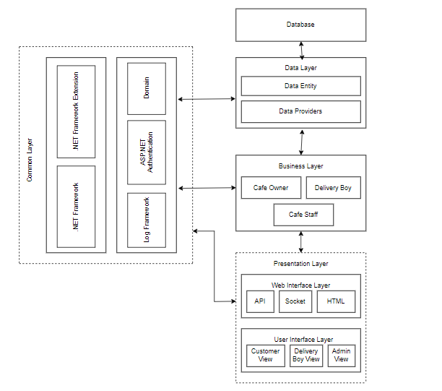

Fig 3.1[Component Diagram]

The RESTFUL architecture style provides core functionalities of the system as web services for different devices and platforms as mentioned in requirements R1, R2 and R5. The MVVM pattern [7] allows developing the User Interface (UI) with clear separation of UI components and presentation logic. The core system has three main layers: Data Layer, Business Layer and Presentation Layer. The Presentation Layer is further divided into two layers, namely Web Interface and UI Layers. These two layers are loosely coupled and connected with web services. All these layers are cross-connected with the Common Layer, as shown in Figure 4.1.

**3.1 DFD ON CAFETERIA MANAGEMENT SYSTEM:**

* Level Zero Diagram:

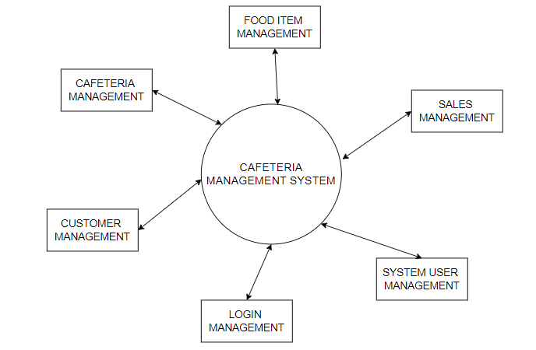

Figure 3.1.1[Level Zero DFD]

* Level One Diagram:

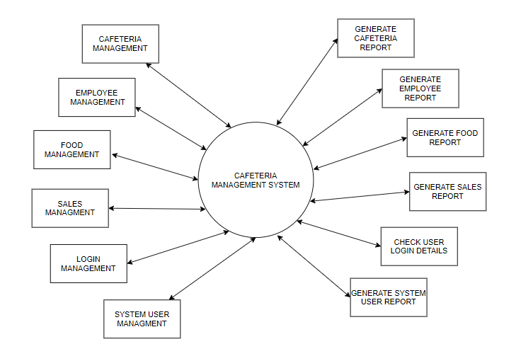

Figure 3.1.2[Level 1 DFD]

* Level Two Diagram:

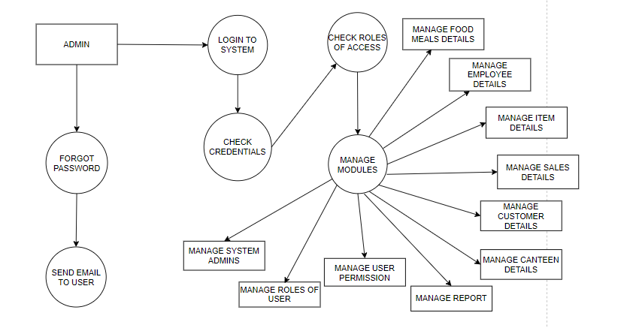

Figure 3.1.3[Level 2 DFD]

* 1. **Use Case Diagram:**

Use-case diagrams describe the high-level functions and scope of a system. These diagrams also identify the interactions between the system and its actors. The use cases and actors in use-case diagrams describe what the system does and how the actors use it, but not how the system operates internally.

Here users and admin are the actors and the working of the system is use cases.

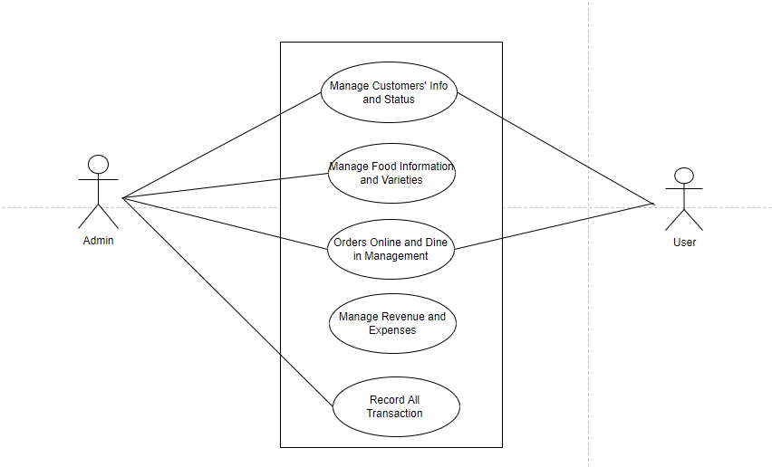

Fig 3.2.1[use case diagram]

* 1. **Sequence Diagram:**

A sequence diagram is a type of interaction diagram because it describes how—and in what order—a group of objects works together. These diagrams are used by software developers and business professionals to understand requirements for a new system or to document an existing process. Here this sequence diagram shows how the system works step by step.

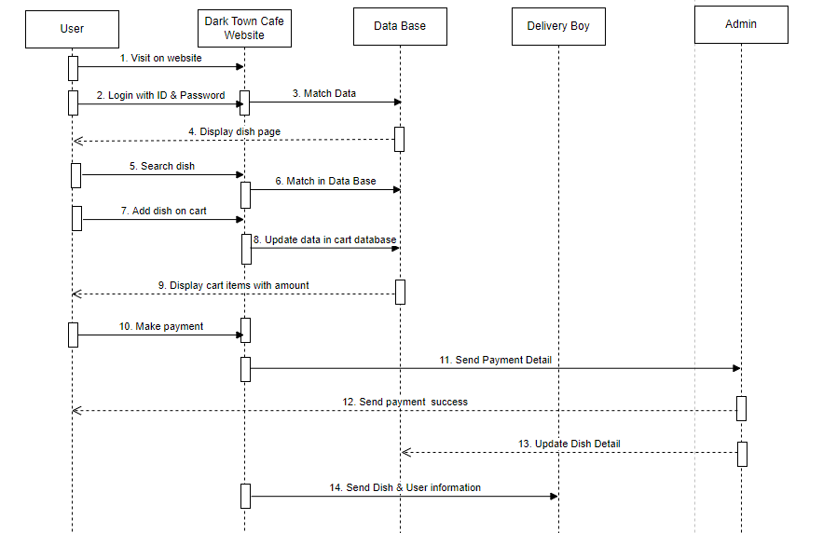

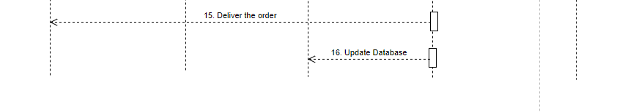

Fig 3.3.1 [Sequence Diagram]

**3.4 Feature/characteristics identification**

There are the following features of Dark Town Cafe:-

1. **Inventory Control:** Dark Town Cafe has an inventory control feature. The System has the option of deducting items from the inventory when the product is sold. For instance, if a fries is sold, the app should subtract the fries from inventory. This way, you know what amount of food you have and how much is required. Inventory is essential as you wish to understand your profit margins by knowing the consumption of food. All the systems should have inventory control or may require third-party integration. So, you should know what all you need for inventory management.
2. **Business Reporting Ability:** Well, Dark Town Cafe also works on a business reporting system or on sending alert messages regarding our cafe to the admin. As a business owner, you don’t have time to evaluate in detail how your business is performing in a particular area. The business reporting system of the management app should be flexible so that it works automatically and sends alerts based on predetermined, user-defined performance indicators. This saves a lot of time and also gives access to all the operations. You can then proactively address the issues that are becoming obstacles in the path of your business growth.
3. **User-Friendly System:** The interface of the website is user friendly and interactive. If any new person comes he/she can easily handle and can easily order their food in a few seconds. The Dark Town Cafe admin panel is also user-friendly. Admin can easily add or delete any food at any time by pressing one click.
4. **Technical Support:** The Dark Town Cafe also provides technical support to users. The website provides live chart facility. Which helps the users if anyone faces any technical issue during ordering the food
   1. **Project Screen Shot:**

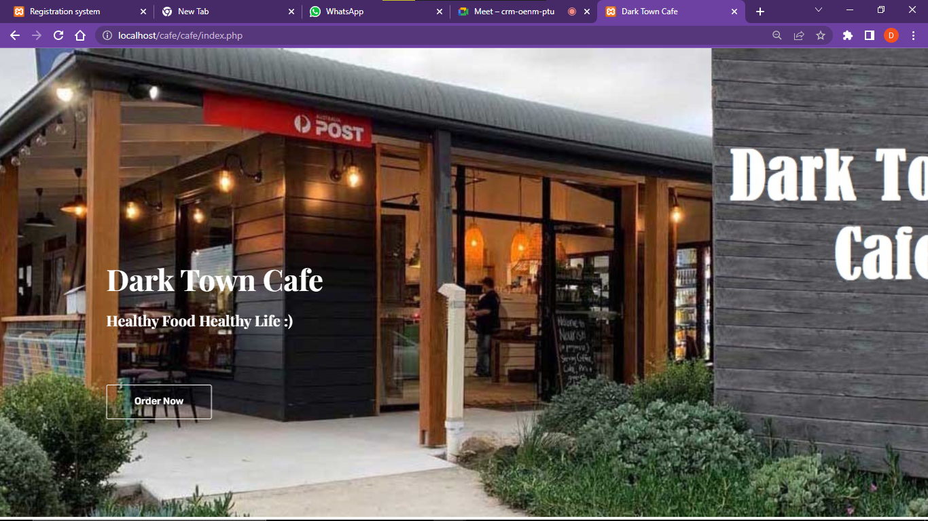

Fig 3.5.1 [User Interface]

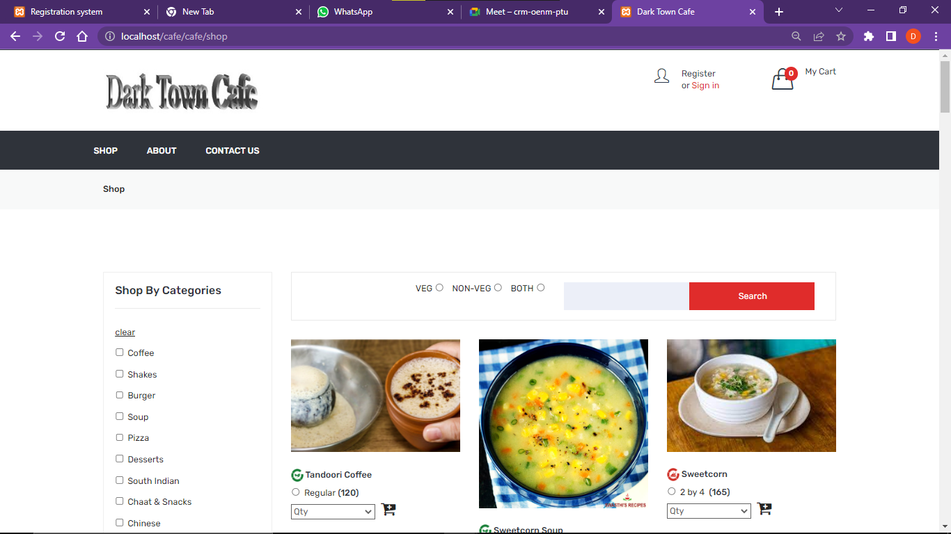

Fig 3.5.2 [Shop page]

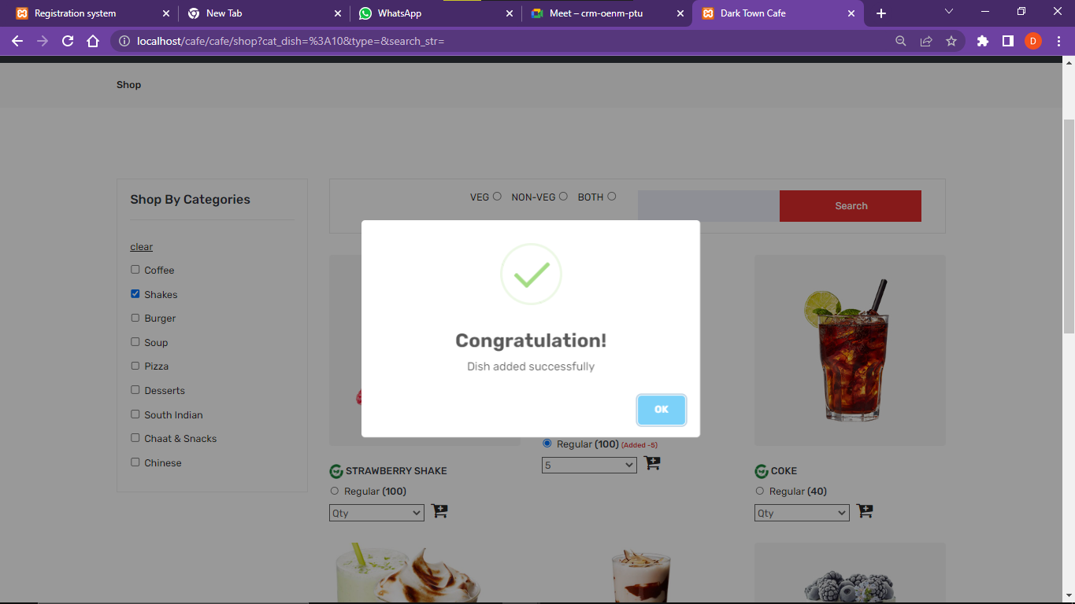

Fig 3.5.3 [Add to cart]

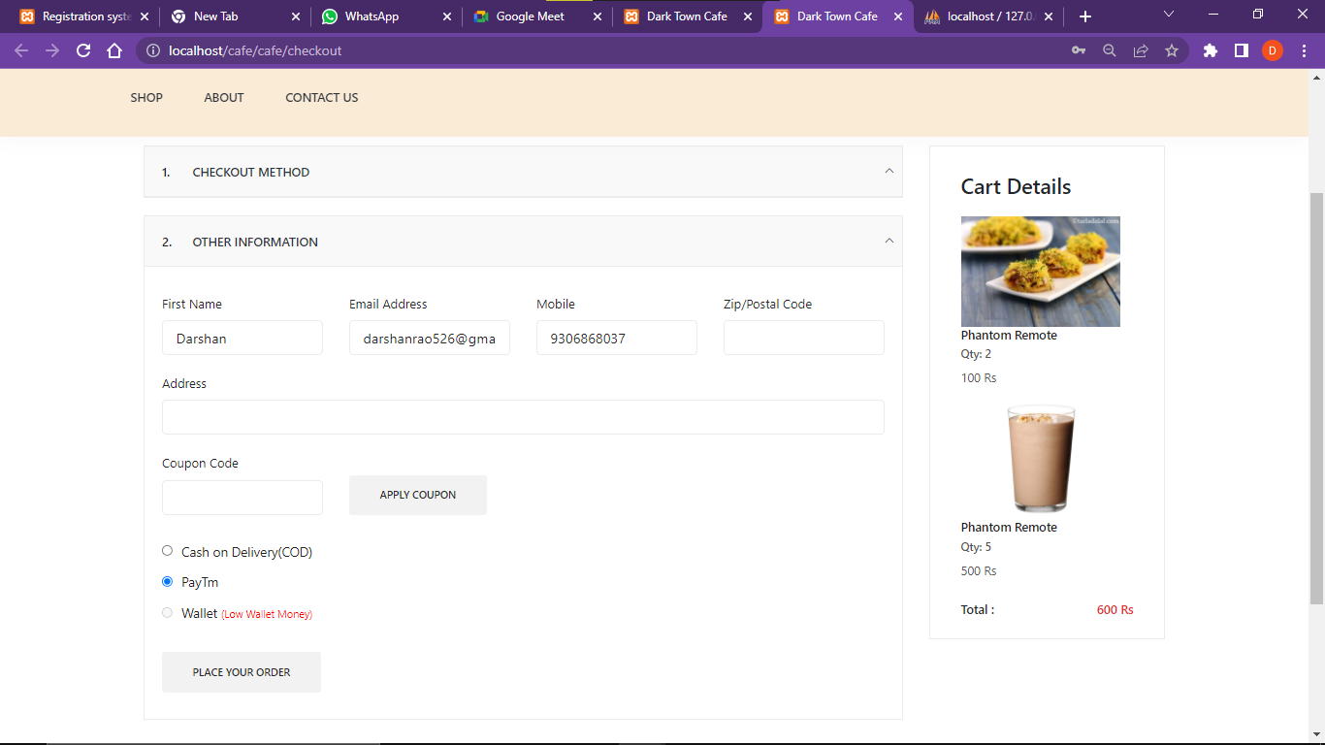

Fig 3.5.4 [Check Out page]

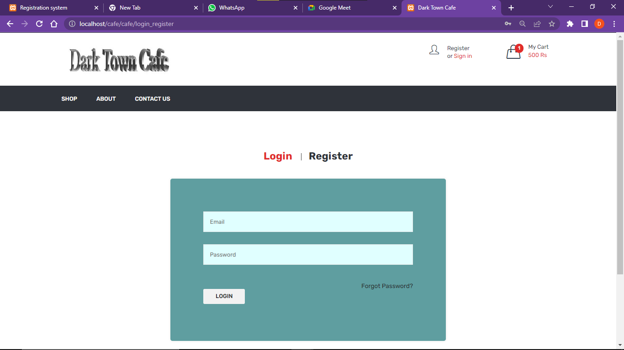

Fig 3.5.5 [Login Page]

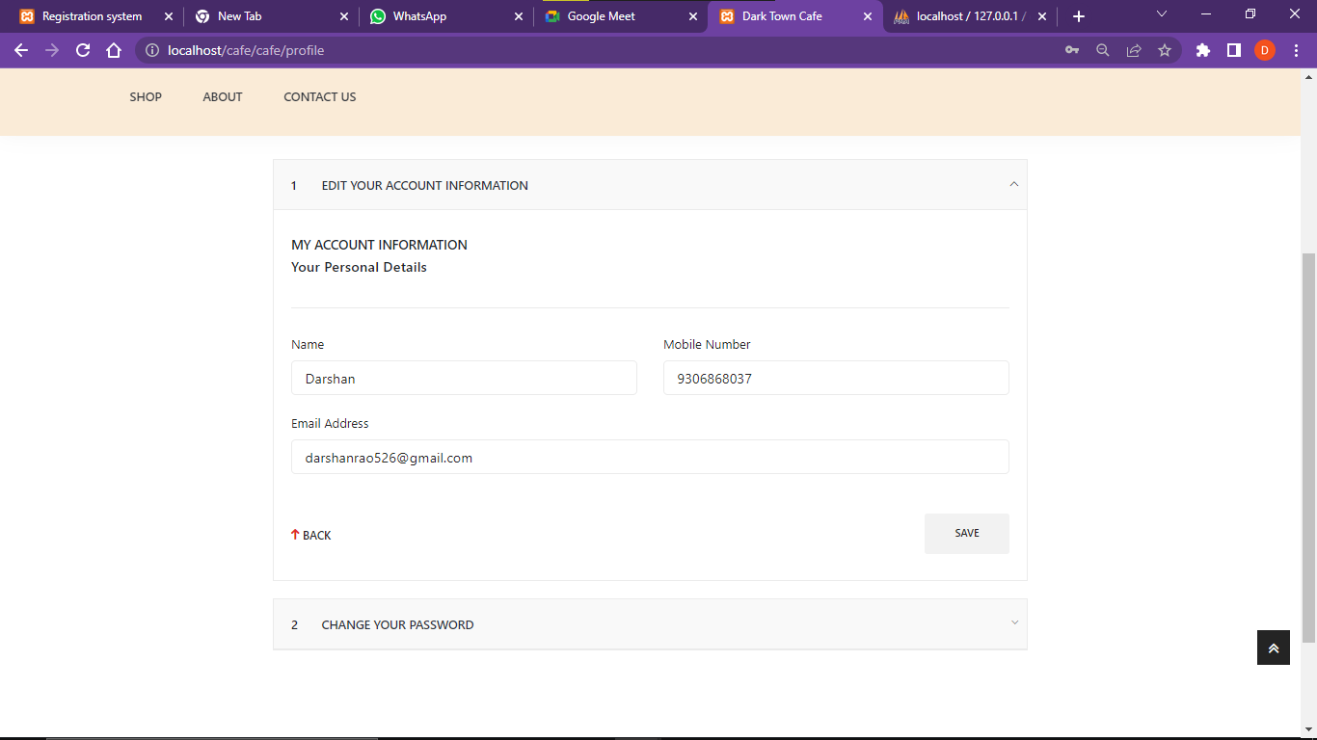

Fig 3.5.6 [Profile page]

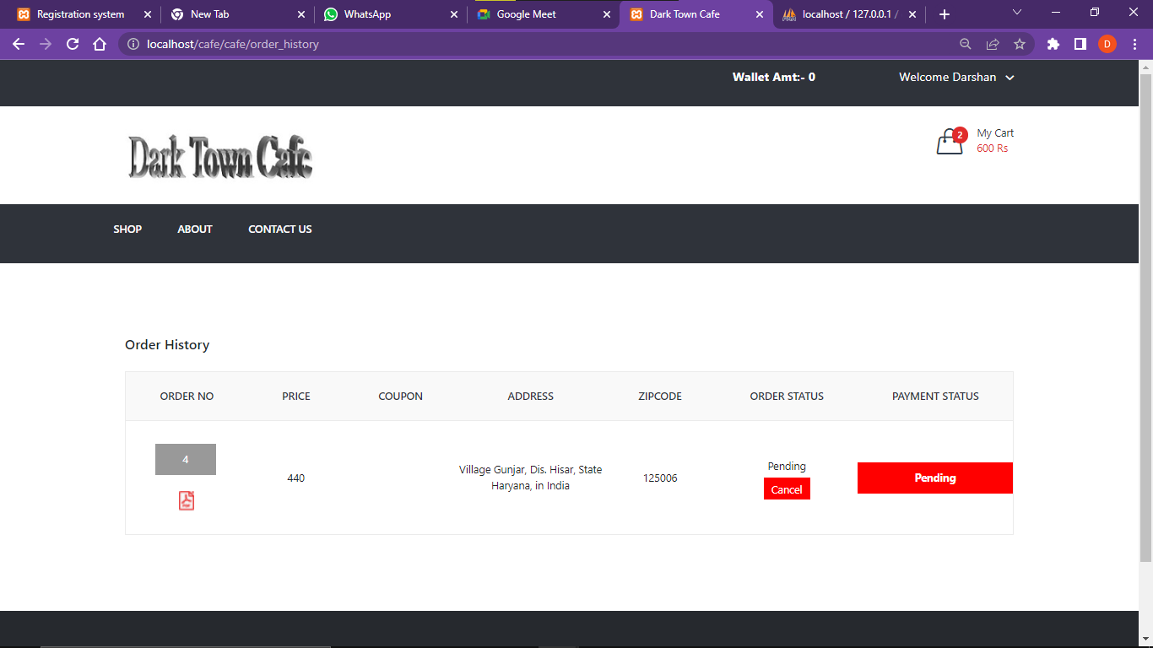

Fig 3.5.7 [Order History]

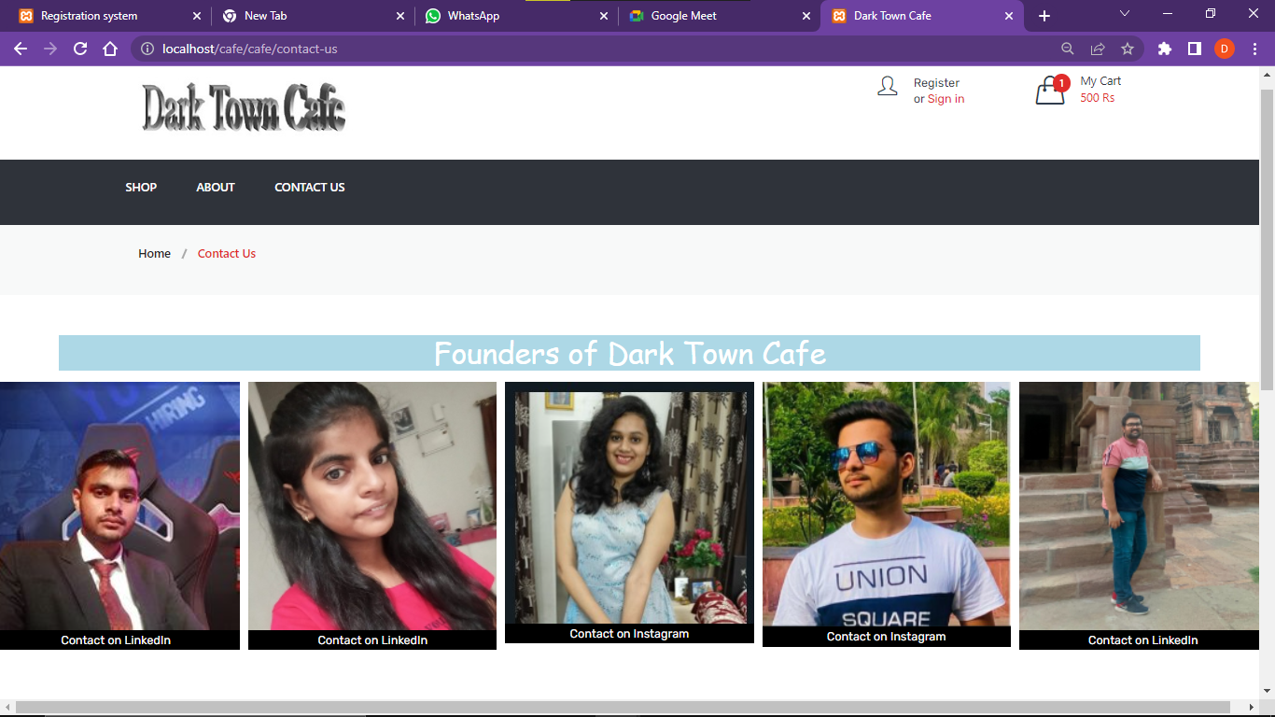

Fig 3.5.8 [Contact us page]

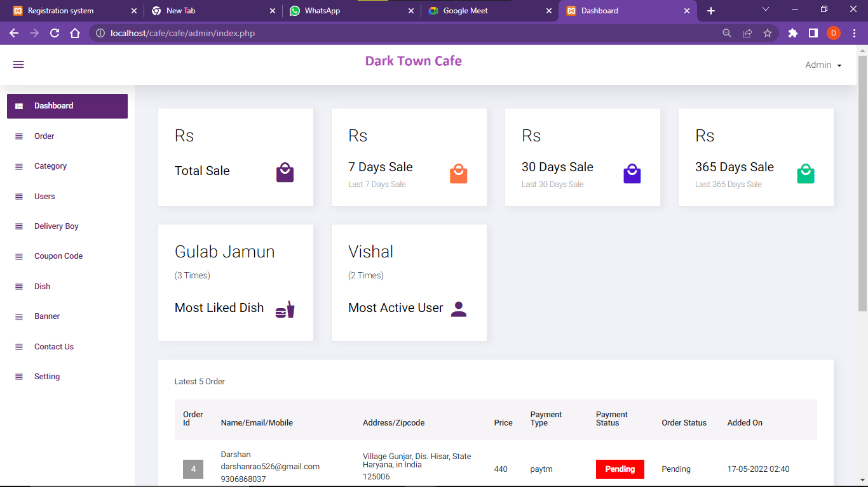

Fig 3.5.9 [Admin panel 1]

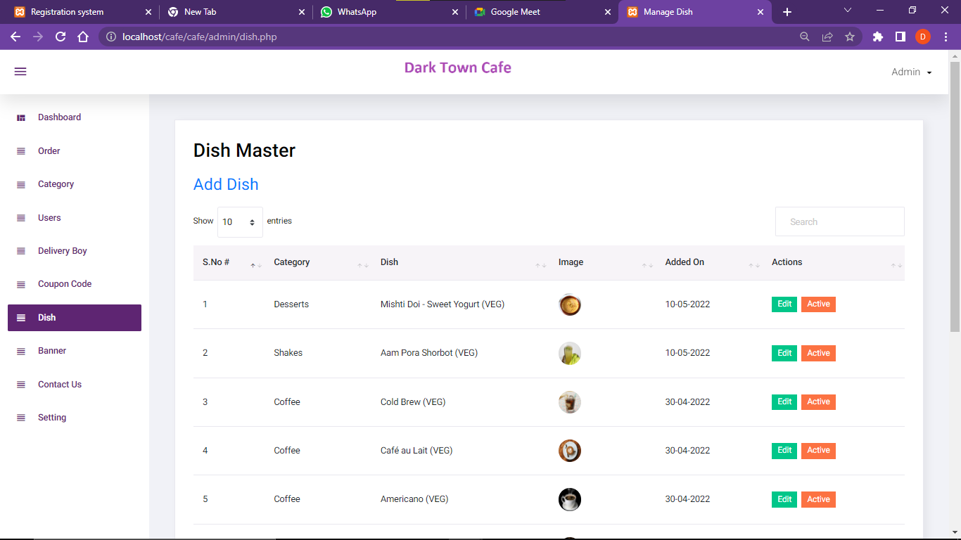

Fig 3.5.10 [Admin panel 2]

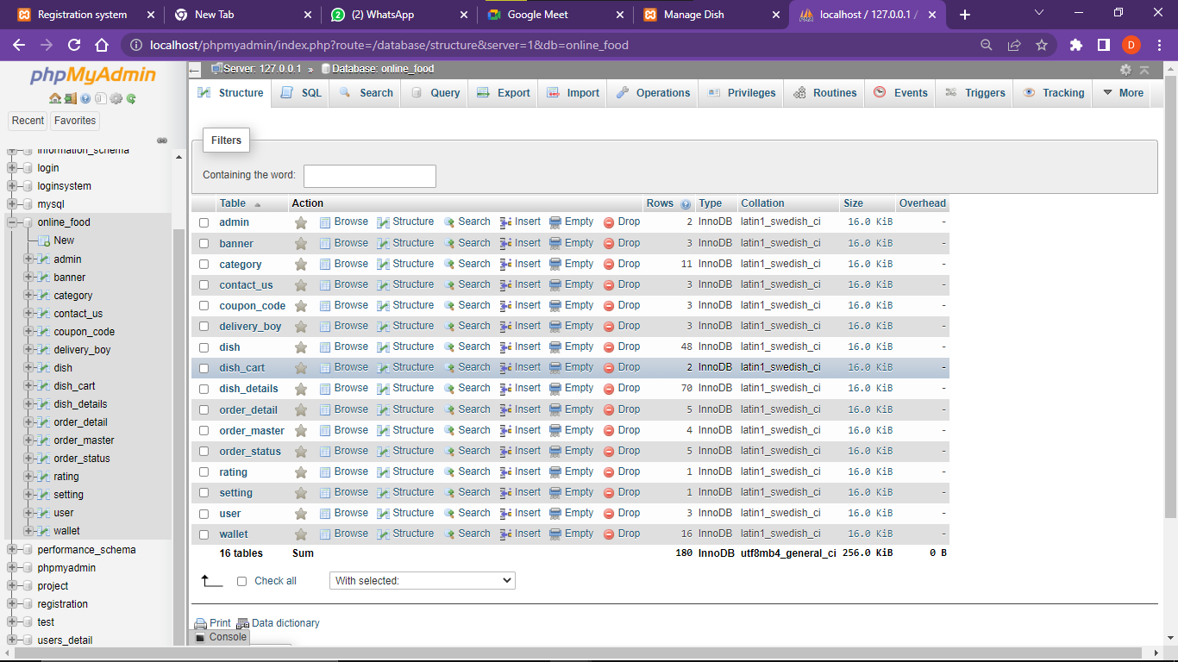

Fig 3.5.11 [Database 1]

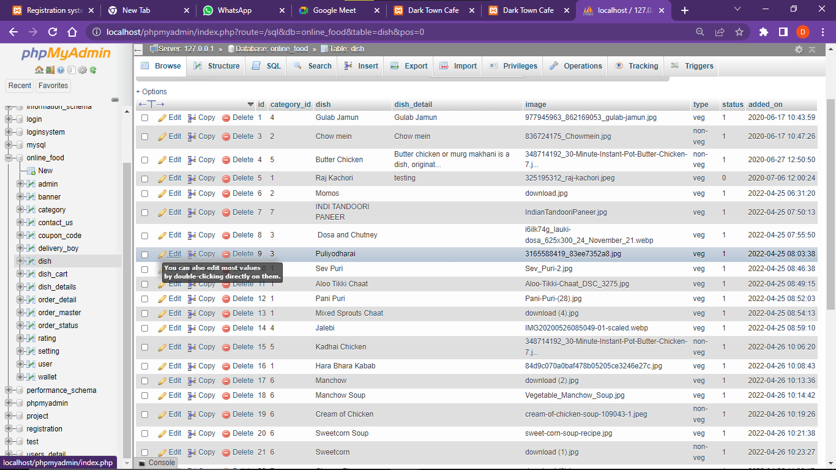

Fig 3.5.12 [Database 2]

**Chapter – 4**

**PROBLEM DEFINITION**

The purpose of any website is to help customers narrow down their broad ideas and enable them to finalize the products they want to purchase. For example, suppose a customer is interested in ordering Chinese food. His or her search for that should list Chinese food categories size and all other features as facets. As the customer selects more and more features or options from the facets provided, the search narrows down to a small list of Chinese food that suit his or her choice. If the list is small enough and the customer likes one of the Chinese foods listed, he or she will make the order.

The challenge is also that each category will have a different set of facets to be displayed. For example, searching for main courses should display their format, as in paperback or hardcover, name, and other facets related to books. These facets were different for Chinese food that we discussed earlier. Similarly, each category will have different facets and it needs to be designed properly so that customers can narrow down to their preferred products, irrespective of the category they are looking into.

The takeaway from this is that categorization and feature listing of products should be taken care of. Misrepresentation of features can lead to incorrect search results. Another takeaway is that we need to provide multiple facets in the search results. For example, while displaying the list of all food, we need to provide facets for a brand. Once a food is selected, another set of facets for other features has to be provided. As more and more facets are selected, we still need to show facets within the remaining products.

**4.1 Problem Statement:**

Traditionally the method in which customers went to a café and then ordered the menu to the waiter who takes the order on a paper personally, he then takes the order to the kitchen department and then he supplies the food item to the customer. So, it was a time-consuming process. It leads to wastage of paper and also it requires reprinting of all menu cards. Also, in many cases for small changes to be made in menu cards it is not convenient to print all menu cards again and again. Simply saying that the menu card once printed can’t be changed. After some days, the menu card lost its worthy look and attractiveness.

Many of the hotels manage their workflow and services by paper work and manually which take time and high budget for management. Busy day of people schedule and value of time become important day by day so Smart Cafe handle the system as booking and ordering by digitally which become save manpower and time of the users. Generating KOT by application is easy to save paper, staff and time. The hotels are services and fertilized in a traditional way, from waiters to kitchen also on account. More recently, this system is one of the major problems for hotels to manage their manpower and guests.

**4.2 PROPOSED SYSTEM:**

There are lots of advantages to having quality cafe management software. What it does is basically decreases the amount of work you have to do usually. Most of the restaurants these days deal larger amounts of cash along with credit cards being swiped, not to forget online orders which make it quite difficult to keep up with everything. This is when restaurant management software becomes important.

In our website the first customer will create his account, after that select the item which he wants to order then select the payment gateway and then process through his order. On the other hand there would be an administrator who would delete the items from the menu list.

**4.3 Project Scope:**

Cafeteria Management System scope of work defines the project purpose, deliverables, and major known risks and constraints. It lays out the basic information to start a cafeteria and is less detailed than a project plan. The primary goal of this website is to reach maximum customers at the right time to increase sales and profitability of the business. Functions of this website include ordering food, booking café for various purposes, managing the data online and in a better manner, transmitting funds or data over the internet. It will save precious time and money.

**4.4 Objective:**

The main objective of this project is to manage the details of cafeteria, sales, and meals. It manages all the information about the cafeteria, meal type, meal. The project is totally built at the administrative end and thus only the administrator is guaranteed the access. The purpose of the project is to build a website to reduce the manual work for managing the cafeteria. It tracks all the details about the sales, product, meal.

Functionalities provided:

1. Provides the searching facilities based on various factors such as cafeteria, sales, product, meal.

2. Manages the meal type details online for product details, meal details, canteen.

3. Tracks all the information of company, meal type, product, etc.

4. Manages the information of the café.

5. Show the information and description of Café sales.

6. To increase efficiency of managing the canteen.

7. Deals with monitoring the information and transactions of products.

8. Manage the information of the canteen.

9. Editing, adding and updating of records is improved which results in proper resource management of café data.

10. Manage the information of the product.

11. Integration of all records of meal.

12. Chat assistant is added to assist new users.

13. This will minimize the number of employees at the back of the counter. This will avoid long queues at the counter due to the speed of execution and number of optimum screens to accommodate the maximum throughput. The system will be less probable to make mistakes, since it’s a machine. The system will help to reduce the cost of labor.

**Chapter – 5**

**RESULT ANALYSIS AND VALIDATION**

**5.1** **Modern Tools Used In Design and Analysis:**

The name ‘Dark Town Cafe’ suggests that this is any cafe website. So we use many programming languages like HTML, CSS, JS, PHP, My SQL, and many more. To handle these languages we use entire initial tools that we need for making any website.

**Software tools:**

* **VS Code**:

Visual Studio Code is a streamlined code editor with support for development operations like debugging, task running, and version control. It aims to provide just the tools a developer needs for a quick code-build-debug cycle and leaves more complex workflows to fuller featured IDEs, such as Visual Studio IDE.

* **My SQL**:

MySQL is an open-source relational database management system. Its name is a combination of “My”, the name of co-founder Michael Widenius's daughter, and "SQL", the abbreviation for Structured Query Language. In Dark Town Cafe this use for making the database of the whole website

* **XAMPP Server**:

XAMPP helps a local host or server to test its website and clients via computers and laptops before releasing it to the main server. It is a platform that furnishes a suitable environment to test and verify the working of projects based on Apache, Perl, MySQL database, and PHP through the system of the host itself.

* **Tawk.to**:

Tawk.to is a site that provides chat bot to Dark Town Cafe. This provides live chat as well as inbuilt chats to the users. Which helps the clients if they face any problem in operating the website?

* **Pinterest**:

Pinterest is a social site where you can collect and share images of anything you find interesting. You can also visually discover new interests by browsing the collections of other [Pinterest users](https://www.lifewire.com/most-popular-pinterest-users-to-follow-3485976). We use this site for collecting all the images for Dark Town Cafe.

* **Sublime text**:

Sublime Text is a shareware cross-platform source code editor. It natively supports many programming languages and markup languages. Users can expand its functionality with plug-in, typically community-built and maintained under free-software licenses. To facilitate plug-ins, Sublime Text features a Python API. The whole Dark Town Cafe website phages are done in the sublime text editor. This is an advanced editor which mainly helps in making HTML, CSS, JS, PHP files.

**5.2 SYSTEM SPECIFICATION:**

The hardware and software requirements for the development phase of our projects are:

**Software requirements:**

* Windows 10/ 11
* VS Code.
* Mysql
* XAAMP Server

**Hardware requirements:**

* Dual-core64-bitprocessor.
* Upto4GBofmemory.
* Upto4GB of internal storage Android SDK:2GB
* WindowsSDK:4GB.
* Network interface card

**5.3 Result Analysis:**

Despite having a lot of constraints and risks, till now we have achieved the feat of minimizing them and we hope to do so in the upcoming phases of the project. After analyzing all the aspects of our project i.e. features and possible constraints, we have decided on certain features and possible constraints, we have decided on certain features for our project that will be suitable.

Major among them are listed below:

**Live Chat:** A feature where your operators initiate the chat and reach out to your website visitors by offering instant help. This is a powerful tool for increasing customer satisfaction and engagement.

**Payment Mode:** Payment is one of the constraints. This is solved by the team of Dark Town Café by providing the feature of all UPI payments, net-banking, credit or Debit card facility and by also providing pay on delivery for some products.

**Analytics and Reporting:** Analytics gives you visibility into key areas of your operation and is arguably the most defining feature of café management software. We can use analytics to know which problems to attack first. We can analyze this using Customer data, Sales and menu analytics and Inventory and procurement analytics.

**Chapter – 6**

**CONCLUSION AND FUTURE WORK**

**6.1 Deviation from expected outcome and ways ahead:**

The main outcome of this project is to manage the details of cafeteria, sales, and meals. It manages all the information about the cafeteria, meal type, and meal. The project is totally built at the administrative end and thus only the administrator is guaranteed the access. The purpose of the project is to build a website to reduce the manual work for managing the cafeteria. It tracks all the details about the sales, product, and meal.

There are the following outcomes that the project reach are:

* **Improve Customer Relationships:**

Well, the Dark Town Café is designed on the basis of improving customer relationships. The website is very user friendly and very interactive. When any new user comes here he/she can easily handle or take their order in a few minutes at any time and anywhere just pressing one click.

* **Tracking Sales:**

These days, the cafe maintains a huge amount of credit card and cash transactions too. Therefore, this Dark Town café site helps to make life easy as the cafe manager by tracking all sales data using [Hybrid mobile app development](https://eibsglobal.com/hybrid-mobile-app-development/). With the help of this data, you will keep tabs on your items sold. This means Dark Town Café also provides the power to make better decisions for your business.

* **Automatic Analysis:**

As a matter of fact, this Dark Town cafe software can automate the report generation. The site is designed in this way the admin can see all the reports of the café on their dashboard like the detail of products, cost, completed and progressed orders. In fact, it produces perfect reports on the impact of implemented marketing schemes like loyalty programs, and discounts, etc on consumer behavior. It helps the business to devise powerful future strategies to improve relationships with existing clients and get new ones.

* **Enhanced Productivity:**

The Dark Town Café site all the products report to the admin. So this helps the admin to enhance productivity of the products very easily. So this is one of the most important outcomes of the Dark Town Café.

**6.2 Achievements:**

Well, we achieved the objectives of our project such as we made the Dark Town Café site as a user friendly and very interactive user interface. We also designed and joined the cart option and payment gateway. For storing the user’s data we use a register and login page. Now come on the admin panel. The admin panel is very user friendly. Here the admin can add, delete and update any dish just pressing one click. Also the admin can see all the sales and profit of the café in the admin panel.

**6.3 Future Scope:**

As we know people are going to do more importance to the time. People like to spend more and more time with technology. So the Dark Town Café provides all the dishes at one place without going anywhere. Anyone can order their food just using their smartphone. It saves time and money. The user can register or login and select the foods and pay the money. The delivery boy can deliver the item in the given time. Not only for users has this website also helped the café owner to handle all the sales very easily. It also provides updation facility to the owner. In future we will go to add the chatbot option also in the Dark Town Café. Chatbot helps the new users if they get any problem during the ordering.

**References**

[1] Tom Matzen, Marybeth Harrison, “Start & run a coffee bar 1st Edition”, Canada, 1997..

[2] Michaela Altmann, “Coffee shop industry – A Strategic Analysis”,

Pittsburgh, March 2007

[3] Wayne Crosbie, Alan Hickman, Garry Blackburn, Alan Macguire, Jim Irwin, “Manage and operate a coffee shop”, Association of Southeast Asian Nations (ASEAN), 2013.

Jim Irwin, “Manage and operate a coffee shop”, Association of

[4] A. Gardner, “7 benefits of business process automation.,” in SOLIDiTech, 2014

[5] L. Brotherton, “5 ways your business benefits from automation,” in ConnectWise, 2016.

[6] N. Bakanowicz, “Why are SMB’s hesitant to embrace new technology?,” in North American Bancard Blog, 2017.

**APPENDIX 1**

Dark Town Cafe (Cafeteria Management System)

### FINAL PROJECT REPORT

***Submitted by***

Yana Srivastava (20BCS2279)

Darshan (20BCS2353)

Prisha Das (20BCS2302)

Tushar Khajuria (20BCS1931)

Harsh Tyagi (20BCS1952)

***In partial fulfillment for the award of the degree of***

**BACHELOE OF ENGINEERING**

**IN**

COMPUTER SCIENCE



**Chandigarh University**

MAY 2022

**APPENDIX 2**



**BONAFIDE CERTIFICATE**

Certified that this project report **“ Dark Town Cafe (Cafeteria Management System)”** is the bonafide work of “ **Yana Srivastava, Darshan, Prisha Das, Tushar Khajuria & Harsh Tyagi”** who carried out the project work under my/our supervision.

**SIGNATURE SIGNATURE**

**SUPERVISOR HEAD OF THE DEPARTMENT**

Submitted for the project viva-voce examination held on 19 May 2022

**INTERNAL EXAMINER EXTERNAL EXAMINER**